**Database Security – Tutorial / Lab 3**

1. Draw an ERD to represent the details provided in the case study below

Case Study

* When a patient is first referred to the hospital, he or she is allocated a unique patient number. At this time, additional details of the patient are also recorded including the name, address, telephone number, date of birth, gender, marital status, registration date
* Details of their consultation with a doctor such as date and diagnosis are also captured.
* Details of the doctors that are stored in the system are staff number, name, department.
* After the doctor sees the patient, he or she may prescribe some medications

1. Consider the ERD shown below:

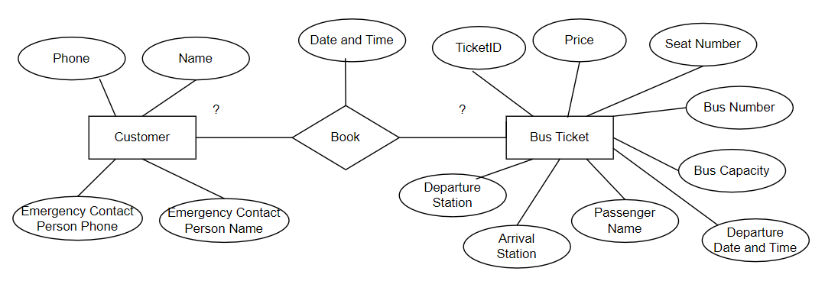

1. Explain the ERD above
2. What should be the cardinality ?
3. Is there any data redundancy that will occur based on this design ?
4. What should be the primary keys for each of the entity ?
5. Where will you place the foreign key(s) ?